1.2: User Research

#### **Introduction**

Welcome back to the world of UX design! Hopefully, you’ve had a chance to explore a few existing platforms for learning and practicing vocabulary. This is a great way to gain basic familiarity with a new industry. Keep these applications on your phone throughout the course as a basis for comparison and source of inspiration. They’ll come in handy once you begin analyzing interface design patterns later in the course.

Researching competitors is a great way to discover solutions that worked and solutions that could use a bit of improvement. That being said, it’s important to not blindly accept existing solutions. There’s no guarantee that these solutions provide the maximum value possible to users (or even any value at all). This is why we need to conduct our own research—to identify the actual needs of our potential users.

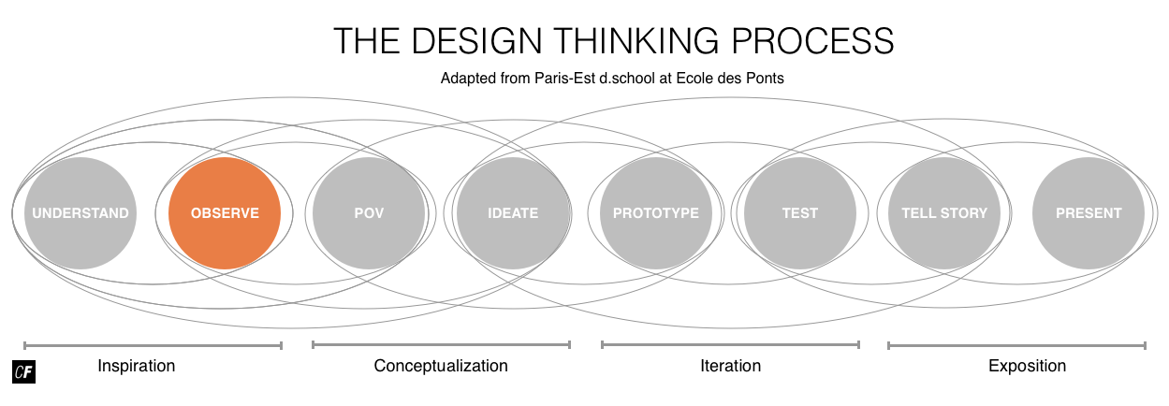

In this Exercise, we’ll move onto the second step in the inspiration phase—“observe.” Engaging with your target audience early and often is crucial to success. Doing so will allow you to test assumptions about your users, your hypothesis statement, and your problem statement. By observing the emotions and thought processes of real people, we can reframe the problem we’re trying to solve in the context of real people instead of make-believe problems.

While effective user research requires more time up front, it ultimately saves time, prevents unnecessary rework, and allows teams to make informed design decisions. In this Exercise, we’ll explore the idea of user-centered design and look into effective user research methods, paying special attention to user interviews.

NOTE  
In this Exercise, you'll get to conduct some interviews with users. You may want to leave yourself some extra time to work on this Task, as you'll need to find and recruit interviewees in addition to writing an interview script. As we begin to dig into some UX theory and practice, you may find that the other Exercises take you longer than the introductory Exercise. Be sure to set aside some additional study time as you figure out a pace for yourself and plan your schedule accordingly.

#### **User-Centered Design and User Research**

**User-centered design (UCD)** is a design method that focuses on placing the users of a system at the center of all development decisions. As Jesse James Garrett, author of the book [The Elements of User Experience](http://www.jjg.net/elements/) explains, “user-centered design means understanding what your users need, how they think, and how they behave—and incorporating that understanding into every aspect of your process.”

In order to effectively employ the principles of user-centered design, you must talk directly to your users to understand how a design can meet their needs and requirements. It’s integral that you engage with colleagues and customers early and often throughout the design process. Even a few degrees off-course early in the planning stages can lead to major miscalculations in trajectory and leave you with products or features that have little to no value. Continual course-correction early on with real customer feedback is crucial. If you’re not engaging with your end users, you’re not practicing user-centered design.

User research is a critical part of the user-centered design process. Think back to the **quadrant model** we looked at in Exercise 1. User research is one of the main quadrants, and it strongly informs experience strategy in the early stages of a project. While not every designer can specialize in conducting user research, a basic understanding is still essential.

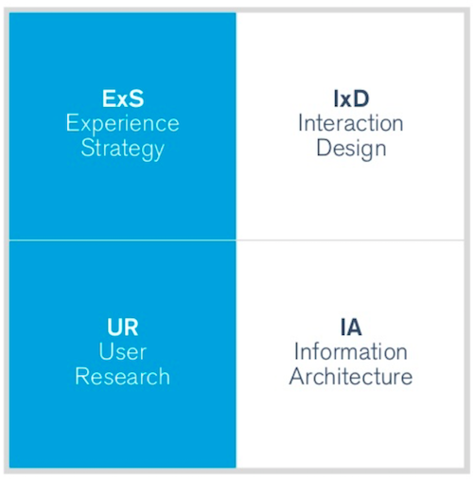

###### **Warren Hutchinson originally created this model.**[**Jason Mesut**](https://www.slideshare.net/planstrategic/ux-hiring-hq)**has since built on the Quadrant Model showing Experience Strategy (ExS), Interaction Design (IxD), User Research (UR), and Information Architecture (IA).**

There are a number of methods designers can use to conduct user research in the user-centered design process. We’ll take a look at a few of the most common ones below.

USERS, HUMANS, CUSTOMERS  
Throughout this course, the terms user, human, and customer will be used interchangeably. This might be confusing at first, but the variety reflects the nuances and fluidity of vocabulary within the industry. Sometimes the term “user” seems overly impersonal, so designers opt to employ more “human” and empathetic language when referring to the people for which they’re designing.

#### **User Research Methods**

Designers practice two types of basic research at various points in the design process: generative (exploratory) research and evaluative research.

**Generative research**, also known as **exploratory research**, is typically conducted upfront and helps designers better understand the problem space. One such example involves using **interviews** as a way to observe the thoughts and feelings of customers regarding the identified problem.

**Evaluative research** is conducted throughout the design process to evaluate how well designers are solving a problem. Usability testing is an important example.

“Human-centered design is a philosophy, not a precise set of methods, but one that assumes that innovation should start by getting close to users and observing their activities.”  
DONALD A. NORMAN, CO-FOUNDER OF NIELSEN NORMAN GROUP

Every project is different, and there’s no definitive checklist when it comes to conducting research. That being said, there are a few key research methods every UX designer should understand. The best user researchers have a deep understanding of the project brief, the industry, and the pros and cons of each method so they can formulate an effective research plan. Because they’ve learned to be creative in how they use the various methods, they also see research methods more as guidelines rather than hard rules.

Christian Rohrer of the Nielsen Norman Group identified a total of [20 different user research methods](https://www.nngroup.com/articles/which-ux-research-methods/) for UX designers to choose from. We’ll explore some of the most important ones here. Since they all have their own merits, it’s up to you to determine which one will most benefit your project. Moreover, the method you choose will also depend on the type of information you’re seeking and the type of user you’re targeting. When you employ each method is just as important as which method you choose, as you’ll find that certain methods are more effective at different stages in the design process.

Most of these research methods can be sorted according to where they fall along two axes: one ranging from attitudinal to behavioral, and the other from qualitative to quantitative. The questions you hope to answer (and the assumptions you hope to validate/invalidate) via your research should determine which method(s) would be most effective. Check out the chart below, which is based on Christian Rohrer’s illustration.

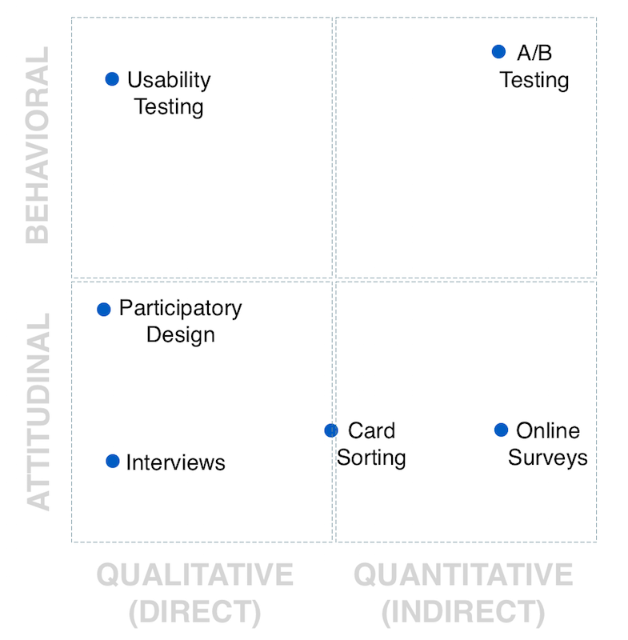

**Attitudinal vs. Behavioral**

Attitudinal research focuses on how people think and feel, while behavioral research observes what people actually do when it comes to a particular product or service. Surveys, user interviews, and focus groups are examples of attitudinal research, because they aim to get to the bottom of why the user likes or dislikes certain features or aspects of your product. Methods such as usability tests, eye tracking, and A/B testing fall under the behavioral research category, as they require you to observe how users actually interact with your product, rather than what they say or think alone.

**Qualitative vs. Quantitative**

Qualitative research involves direct observation of a subject. In-person interviews, for instance, would be a great example. Quantitative research, on the other hand, represents data-driven, indirect observations such as survey responses or users’ usage data.

Now that we’ve identified the four key groups user research methods fall under, let’s take a look at some of the most common methods in each group.

##### **Surveys**

**Surveys** are a common, indirect method of obtaining attitudinal information on how people feel about your product or service. Survey results can be qualitative if participants are prompted to respond to open questions, but surveys are most useful when collecting quantitative data from a statistically significant amount of participants. There are any number of ways you could recruit survey participants. For example, you could “intercept” users while they’re interacting with a website or application using what are appropriately called intercept surveys, or you could send your survey to a target group of users via email.

Keep in mind that writing good survey questions is more difficult than it seems. Knowing the exact questions necessary to procure the types of answers you need takes considerable practice, and even then, you can’t always guarantee participants will answer appropriately. With practice, however, you'll learn how to word questions (and what questions to ask!) to get accurate, useful information from your participants.

* Pros: Surveys are quick and inexpensive, and they allow you to collect feedback from those you can’t interact with directly in an asynchronous fashion—once the process is in motion, it will operate independent of your input. This means you can sit back and relax while the responses roll in.
* Cons: What people say is often very different from what people do. Surveys give us great insight into what people say they do, but not necessarily what theyactually do. It can also be difficult identifying how to fix the problems they have (you can't follow up with a quick question the way you would in an interview). Lastly, many people don’t particularly enjoy filling out surveys, which could lead to self-selection bias and skew your demographic pool.
* When to Use: Time, cost, and geographic limitations could make surveys an attractive option. That being said, it’s more preferable to observe people directly through methods such as user interviews and usability tests whenever possible.

##### **Participatory Design**

**Participatory design**, also known as cooperative design or co-design, is a collection of methods, both qualitative and quantitative, aimed at engaging every single stakeholder—colleagues, clients, and customers alike—in the design process. One example is a design workshop, in which developers and designers work on a prototype together. Another is a **card sort**, a method for organizing and creating intuitive structures and categories. We’ll be looking more at card sorts later in the course.

* Pros: Good ideas can come from anywhere. Involving people from different backgrounds in the design process will bring unique perspectives you may not have considered otherwise. This can help you create a better, more intuitive design for your customers. It also allows colleagues and clients to collaborate in a visual and productive way.
* Cons: Involving people in the process is critical, but you can’t allow them to make every design decision for you. After all, the more people involved in something, the more conflicting points of interest could arise, taking up more of your time and potentially creating conflicts among team members.
* When to Use: Participatory design is especially effective when working with new clients, colleagues, and customers. It’s a great way to make sure everyone is on the same page, work out unspoken requirements, and develop rapport with a new team and target audience.

##### **Usability Tests**

**Usability tests**, like their name implies, involve testing the usability of your product on a set of users. They’re a great way to evaluate what people say and do when interacting directly with your product or service. Most often, the users are given a specific set of tasks to complete, and the efficiency, ease, and speed with which they can complete them are recorded. Keep in mind that it’s not the participants themselves being tested, but the effectiveness of the product or service you’ve designed.

* Pros: An effective usability test reveals how a typical user would attempt to complete a task using your product. It can also grant insights into how to fix problems that may arise during the test. Researchers can observe where people go wrong, take notes, and make steps to course-correct.
* Cons: Recruiting users within a particular target market can be time-consuming and expensive.
* When to Use: Usability tests are an effective way of obtaining feedback and can be conducted in person or remotely using online tools and platforms such as[UserTesting](https://www.usertesting.com/) or [UserZoom](http://www.userzoom.co.uk/" \t "_blank).

TIP!  
For a better idea of what usability testing is all about, sign up for [UsabilityHub](https://usabilityhub.com/" \t "_blank). You can participate in other designers’ usability tests to gain insight into how they’re conducted.

##### **User Interviews**

**User interviews** are a qualitative method of user research comprising an in-person interview aimed at better understanding a user’s attitude towards a product or service. Similar to surveys, the quality of information you obtain is entirely dependent upon the questions you ask; however, you’ll also have the chance to ask follow-up questions for more detailed information.

* Pros: Interviews allow researchers to develop a relationship with the target audience through direct communication. A script provides a basic guide, but the interviewer is free to follow diverging conversation threads and explore a new space. The direct contact with participants allows you to pay attention to their body language and tone of voice, as well.
* Cons: There are very few negative aspects about directly communicating with your customers. Most businesses don’t do it enough. It can, however, be difficult to gain access to certain target audiences if the project involves sensitive information, but you shouldn’t have that problem with your course project.
* When to Use: The keys to a good interview are a solid script and an environment that allows for natural conversation. This can be achieved in person or online and is a great way to kick off a project or explore a new problem space.

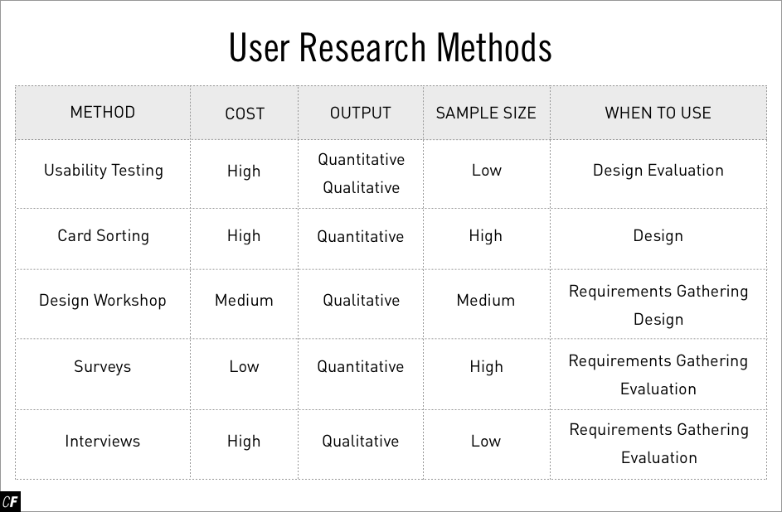

As we’re still in the “observe” step of the design thinking process, we’ll focus on a research method entirely dependent on observation—user interviews. Later on in the course, you’ll have a chance to experiment with the other user research methods discussed above.

#### **Writing a Script for Your User Interview**

User interviews are only as successful as your questions allow them to be. You need to be asking the right questions in the right order to obtain useful feedback—that which either validates or invalidates your current design strategy and direction. Good questions give us good data, and only with good data can we make informed design decisions. That’s why it’s crucial to prepare a list of questions in advance so that you can compare the answers given to you by your interviewees. Asking each participant different questions will result in unbalanced, disorganized data that will be difficult to summarize and validate.

It’s important to note that you’re not asking people to come up with solutions—that’s your job as the UX designer! The goal is to uncover the fundamental needs and pain points when learning something new, as well as the accompanying bundle of unknown vocabulary. To avoid a checklist of proposed solutions from their interviewees, user researchers ask simple, open-ended questions that are focused on a person’s actual behavior. Their questions attempt to wrest the “why” rather than the “what” from their participants, which is essential in determining the underlying problem that needs to be solved.

An immense amount of literature has been written on the subject of interviews. The best guideline to start with is to keep it simple—you can always dig deeper later. We’ve outlined some best practice tips for writing good questions below. Keep them in mind as you’re writing your first user interview script.

##### **Know What You’re Looking for**

Tailor your script to address various elements of the problem you’re trying to solve. You want to keep your interview short, but you also want to ensure you get the best information possible. Get right to the point!

**Example Question**: “What do you enjoy about learning new vocabulary?”

##### **Keep Your Questions Simple**

Your project has barely gotten off the ground at this point. You’re still in exploration mode. Keep your questions short and simple—interviewees should have no problems digesting the questions. You can encourage them to talk more and provide additional details in the interview itself.

**Example Question**: “When did you last need to study vocabulary for something?”

##### **Don’t Ask Leading Questions**

Avoid asking questions that hint at a particular desired response. People should feel free to respond candidly, not feel pressured to give you the right answer.

**Example Question**: Instead of asking “Would a program that included the ability to save flashcards to different decks be useful for you?” ask “What features do you think would be most useful to you in a flashcard program?”

##### **Ask Questions that Reveal Actual Behavior**

You want to identify tangible examples of behavior whenever possible. Do this by focusing on specific accounts of actual behavior. This will encourage interviewees to explain not only what they say they do, but what they actually do.

**Example Question**: Instead of asking: “Do you study a lot?” ask “How many times have you actively studied vocabulary in the last year?”

##### **Keep Asking “Why”**

Encourage your interviewees to dig deeper by following up all answers with “why?” Keep digging until you find the fundamental motivation for their behavior or the source of their problem.

**Example Question**: “You mentioned being frustrated by the method you used. Can you tell me more about why you felt that way?”

##### **Don’t Ask Yes or No Questions**

You won’t be able to glean much qualitative data from one-word answers.

**Example Question**: Instead of “Have you ever used a language learning program before?” ask “When you last tried to learn new words, what did you use to do so?”

MORE ON QUESTION GUIDELINES  
For more specific guidelines on question structure, refer to the Helsinki Design Lab’s “[Ethnography Field Guide](http://helsinkidesignlab.org/pages/ethnography-fieldguide.html).” While it was written with a different kind of study in mind, the question format examples can still be useful in writing effective interview scripts.

We’ve put together a few examples of questions that you could ask for your own project based on the above guidelines:

* Are you a student, professional, or both? Tell me more about your responsibilities and daily routines.
* What was your first day of class like? What were your biggest challenges in starting a new class/job/project? Why?
* When was the last time you had to learn a good deal of new vocabulary? Did you succeed? Why or why not?
* Tell me about a time you’ve been frustrated with jargon and new vocabulary. Why was it frustrating? Is there something that could have made it easier for you?
* Why do you think learning new vocabulary is difficult?

Now that you’re armed with plenty of tips and examples, why not give it a shot yourself? Download this interview script template ([PPT](https://s3.amazonaws.com/coach-courses-us/public/courses/ux-fundamentals/E2/userinterviewstemplate.pptx), [Keynote](https://s3.amazonaws.com/coach-courses-us/public/courses/ux-fundamentals/E2/userinterviewstemplate.key), [PDF](https://s3.amazonaws.com/coach-courses-us/public/courses/ux-fundamentals/E2/userinterviewstemplate.pdf)) and spend around five minutes jotting down a few questions.

#### **Choosing Your Interviewees**

For the purpose of this introductory course, you'll probably want to stick to interviewees you already know and that are readily available—family, friends, colleagues, or anyone who'd be willing to participate in an interview for your project. As you progress further in your UX design career and take on bigger projects for clients and companies, you'll want to move past interviewing family and friends to interviewees that can have a bigger impact on your research and results.

It's ultimately up to you to determine your target audience for your research. You would need to have access to them for an interview (either in-person or via phone or video call), and they would need to have insights pertinent to your project. In this course, you'll be designing a vocabulary learning app, so you'd ideally want to interview people who've engaged in some sort of educational or vocabulary-learning activity within the past couple of months. Those with experience in learning vocabulary would be able to offer you better insights into how it worked for them than someone who's never touched a vocabulary app or even flashcards. Likewise, if you were designing a travel app, you wouldn't want to interview someone who's never left their hometown, or if you were designing a food delivery app, you wouldn't want to interview someone who never orders food.

In addition to the theme of your project, you need to think about the medium, as well. If you're designing an app for a mobile phone, interviewing someone who's never used a smartphone before wouldn't offer you much insight. The age, hobbies, and background of your interviewees all matter. While you may not be able to find the perfect interview candidates at this point in your UX career, you can try and narrow your search as much as possible (for instance, interviewing a sibling or cousin rather than your technologically-challenged grandmother).

#### **User Interview Best Practices**

Have you finished your script? Great! Having a list of the questions you want to ask will take some of the pressure off the interview itself. For those who’ve never conducted an interview before, though, it can still be a little intimidating. Let’s take a look at some best practices for conducting interviews to get you off on the right foot.

* **Keep it natural.** Treat your interview like any other natural interaction. Introduce yourself, provide a bit of context to set up the conversation, and try to create a welcoming atmosphere. This will put your interviewees at ease so they can feel comfortable sharing their thoughts and behaviors candidly.
* **Focus on people over paper.** User researchers typically conduct interviews in sets of two. One researcher asks the questions and engages in conversation while the other takes notes. For your project, you’ll likely be on your own. That’s okay! It just takes a bit more balance. The important thing is to focus on engaging with the interviewee instead of transcribing every word into your notes.
* **Use the script as a guide.** User interviews should be conversational in nature. Remember that you’re still in exploration mode, so you’ll likely broach topics you hadn’t thought of ahead of time. Feel free to deviate from your script to follow an interesting topic. If you feel the conversation isn’t generating any useful insight, refer back to your script to refocus and move on.
* **Embrace the silence.** In normal conversation, silence can create awkward moments. We tend to rush to fill these silences to avoid that discomfort. In research, however, you should let your interviewee fill the silence. You might miss out on an interesting insight if you finish thoughts and sentences for them. If your interviewee is stuck, help them by restating the question or moving on to a new one.
* **If you record, let them know!** It’s important to note that if you’re recording an interview, you should always let your interviewee know. Tell them how you’re capturing the conversation, as well as who will have access to the information.

MORE ON INTERVIEWS  
For a more comprehensive look at user interviews and usability testing, check out this article: [How to Conduct User Experience Research Like a Professional](https://careerfoundry.com/en/blog/ux-design/how-to-conduct-user-experience-research-like-a-professional).

#### **Summary**

In this Exercise, we talked about the different types of user research you can conduct over the course of a user-centered design process. Doing this research at various stages in your design cycle is critical in confirming your users’ thoughts, desires, and needs. Failing to conduct good user research can often lead to the release of an ineffective product or service your users don’t want. Some of the most common user research methods include surveys, participatory design, usability tests, and interviews. You’ll get a chance to try out these methods further along in the course. For now, however, let’s get started with interviews.

#### **Resources**

**General**

* [Design Thinking: An Overview](https://www.interaction-design.org/literature/article/design-thinking-a-quick-overview) https://www.interaction-design.org/literature/article/design-thinking-a-quick-overview
* [UX Research Methods](https://blog.prototypr.io/ux-research-methods-acb80b141bdc#.u6fzxe44n) https://blog.prototypr.io/ux-research-methods-acb80b141bdc
* [How to Conduct User Experience Research Like a Professional](https://careerfoundry.com/en/blog/ux-design/how-to-conduct-user-experience-research-like-a-professional) https://careerfoundry.com/en/blog/ux-design/how-to-conduct-user-experience-research-like-a-professional

**User Interviews**

* [Interviewing Users](https://www.nngroup.com/articles/interviewing-users/)
* [Ethnography Field Guide](http://helsinkidesignlab.org/pages/ethnography-fieldguide.html)
* [User Interviews: The Beginner’s Guide](http://theuxreview.co.uk/user-interviews-the-beginners-guide/)
* [Usability Testing Script by Steve Krug](http://sensible.com/downloads/test-script.doc)
* [Recording Consent Form (Permission Form Template) by Steve Krug](http://sensible.com/downloads/permission-form.doc)
* [Checklists by Steve Krug](http://sensible.com/downloads/checklists.doc)
* [Instructions for Observers by Steve Krug](http://sensible.com/downloads/instructions-for-observers.doc)
* [Hall Monitor’s Guide by Steve Krug](http://sensible.com/downloads/hall-monitor-guide.doc)
* [More Usability Document Templates from Usability.gov](http://www.usability.gov/templates/)

**To create survey use website -**

[**https://www.google.com/forms/about/**](https://www.google.com/forms/about/)

[**https://goo.gl/forms/u4yX8LQKJvmVHkrf2**](https://goo.gl/forms/u4yX8LQKJvmVHkrf2)

***Hello everyone, I am doing task2 on "User research - Learning with apps", to collect user reaction, I need your help. It is small survey, it will take only 10 min to complete and help me a lot. Here is link to access it. https://goo.gl/forms/HSNjI0M2Q9wMg0SW2***

***Enjoy your day.***